Lab Assignment No: 01

NAME: Vivek Vikram Pundkar ROLLNO: 77

CLASS: C                    BRANCH: ENTC                        BATCH: 3

DATE OF PERFORMANCE: 07-09-2021

1. Change your password to a password you would like to use for the remainder of the semester.

=> sudo passwd vivek

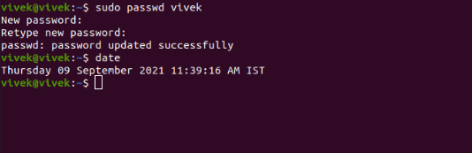

2. Display the system’s date.

=> date



3. Count the number of lines in the /etc/passwd file.

=> wc -l /home/vivek/Documents/lab1.txt

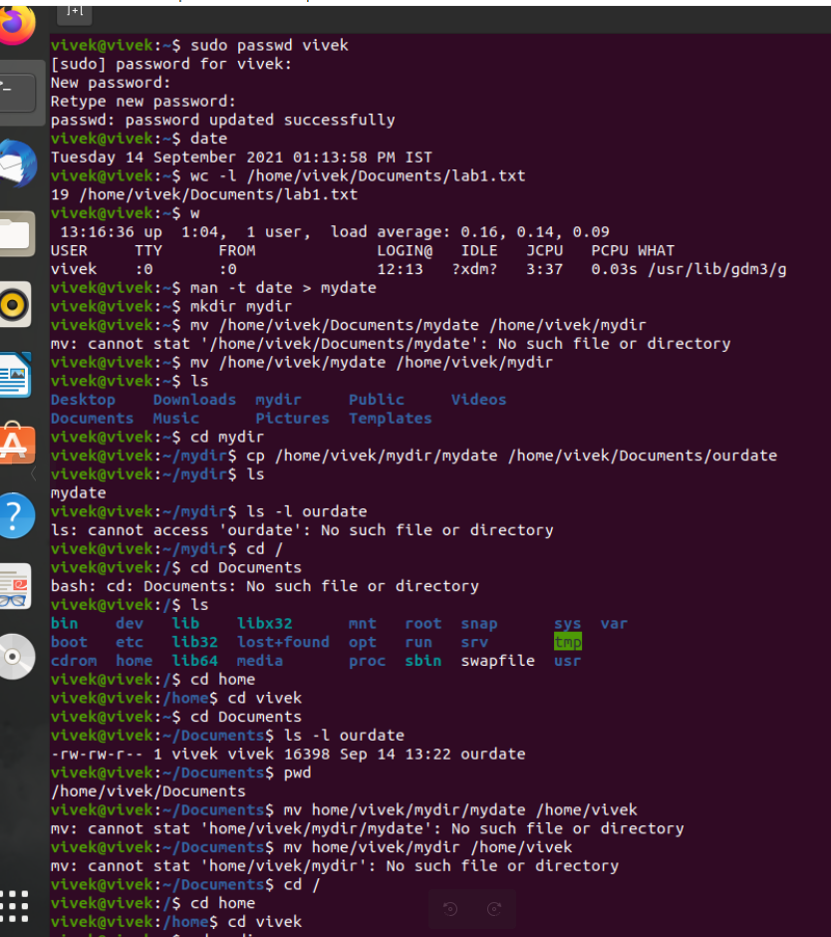

4. Find out who else is on the system.

=> w



5. Direct the output of the man pages for the date command to a file named mydate.

=> man -t date > mydate



6. Create a subdirectory called mydir.

=> mkdir mydir



7. Move the file mydate into the new subdirectory.

=> mv /home/vivek/mydate /home/vivek/mydir



8. Go to the subdirectory mydir and copy the file mydate to a new file called ourdate

=> cp /home/vivek/mydir/mydate /home/vivek/Documents/ourdate



9. List the contents of mydir.

=> ls



10. Do a long listing on the file ourdate and note the permissions.

=> ls -l ourdate  


11. Display the name of the current directory starting from the root.

=> pwd  


12. Move the files in the directory mydir back to your home directory.

=> mv home/vivek/mydir/mydate /home/vivek/  
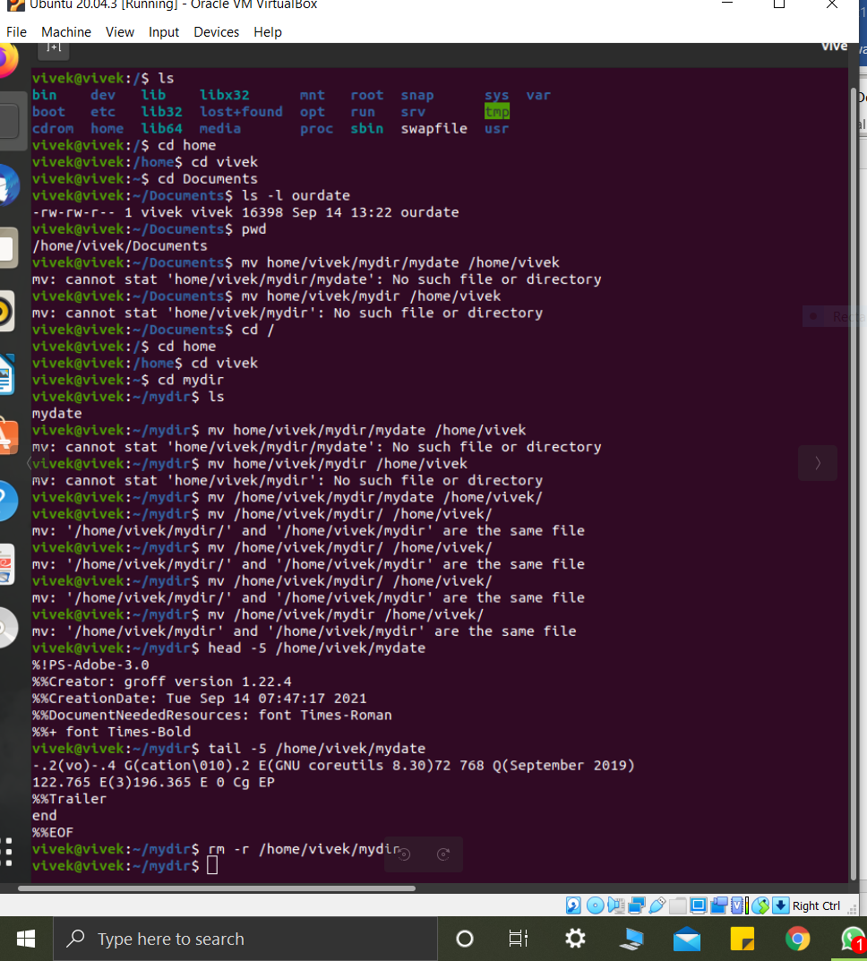 

13. Display the first 5 lines of mydate.

=> head -5 /home/vivek/Raul/mydate  


14. Display the last 8 lines of mydate.

=> tail -5 /home/vivek/Raul/mydate  


15. Remove the directory mydir.

=> rm -r /home/vivek/Raul/mydir

